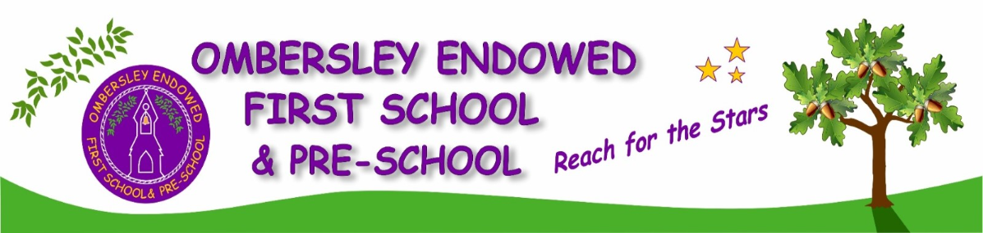
CURRICULUM NEWSLETTER
YEAR 2 • AUTUMN TERM 1
Welcome to Year 2!
We have made a great start to our new school year. This newsletter gives a brief overview of the learning that we will be doing over the next half term.

ENGLISH
In English this half term, Our focus texts are The Colour Monster Goes to School, Field Trip to the Moon, What the Worm Saw, Once Upon an Ordinary School Day, and The Great Explorer. We will use a range of time words to begin sentences and practise using “because,” “that,” and “and” in our writing. We will also explore different question openers and use question marks correctly. Finally, we will create expanded noun phrases containing more than one adjective.
In our reading lessons, we will focus on different text extracts and then practice answering questions about them. We will practicing our vocabulary knowledge, inference, prediction, explanation, retrieval and sequencing skills. Our handwriting is practiced daily at the start of our writing lessons. We practiced different letters and how they sit on the line. Our spellings are linked to our text in writing. They will cover the common exception words for year 2 and the key spelling rules in year 2.

MATHS
This half term, we will begin with place value before moving on to addition and subtraction. We will recognise tens and ones, partition numbers, position numbers on a number line, and estimate values up to 100. We will also compare numbers to 100 and count in 2s, 3s, 5s, and 10s.
In addition and subtraction, we will revisit number bonds to 10 and use this knowledge to find number bonds to 100. We will then practise adding by making 10, combining three one-digit numbers, and adding across a multiple of 10.

SCIENCE
This half term, our topic is living things and their habitats. We will recall key life processes and explain how they apply to plants and animals. We will match plants and animals to their habitats and describe how animals use them for food and shelter. We will also learn that plants make their own food for energy, identify producers, place them at the start of food chains, and use arrows to show the direction of each chain.

HISTORY
This half term, our focus is, ‘How was school different in the past?’. We will explore what schools were like in the past and compare them with schools today. We will discuss the similarities and differences and decide whether we would prefer to attend a modern school or one from the past. During our trip to the Black Country Museum, we will visit a historic school and experience a traditional lesson.

DT
This half term, we will study mechanisms by designing a fairground wheel. We will explore how axles allow wheels to turn, evaluate different designs, and label our own working model. After comparing material properties, we will select suitable materials, build a stable structure, and test each component. Finally, we will assess how well the wheel rotates and refine our mechanisms.

PE
This half term in PE, we will focus on ball skills and fundamental movements. In our ball skills lessons, we will practise controlling a ball with our hands, feet and equipment. In our fundamentals lessons, we will develop movements such as running, skipping, and jumping. We will also learn to control our speed when running and perform a range of jumps.
PE days are Wednesday and Friday. Please ensure that children come to school wearing PE kit on these days.

COMPUTING
We will begin our computing lessons with e-safety, exploring how avatars are used and why people online may not be who their avatars suggest.
We will then begin our Creating Pictures topic. The children will produce digital artwork inspired by Impressionism, Pointillism, Piet Mondrian, and the Arts and Crafts movement before compiling their work into a digital portfolio.

RE
This half term children will learn about Matthew the Tax Collector and how Christians believe that Jesus offers forgiveness, looking at their heart rather than what they have done in the past. Children will learn about the Bible and what it means to Christians.

PSHE
This half term children we will learn about Very Important People (VIPs) in their lives and the ways in which they can develop positive relationships with them. Children will learn to identify what makes someone a special person in their life and who these special people are. Children are also encouraged to explore why families and friendships are important and to understand that although these units are different for everyone, there are things they can do to resolve differences and build healthy and positive relationships within them. We will look at the importance of cooperation and how to show the special people in their lives that they care, as well as the positive impact of doing this

